LAB TASK-3

#include<stdio.h>

int main()

{

int n, i, search;

printf("enter the value of n:");

scanf("%d", &n);

int a[n];

printf("enter the array elements :");

for(i = 0; i < n; i++)

{

scanf("%d", &a[i]);

}

printf("the array elements:");

for(i = 0; i < n; i++)

{

printf("%d\n", a[i]);

}

printf("number to be search :");

scanf("%d", &search);

for(i = 0; i < n; i++)

{

if(a[i] == search)

{

printf("%d is at %d index", search, i);

break;

}

}

if(i == n)

{

printf("not found");

}

return 0;

}

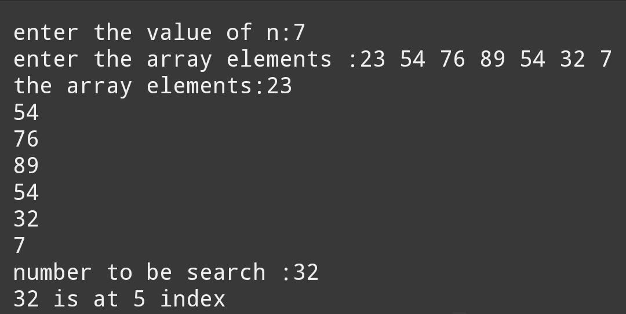

#include<stdio.h>

int main() {

int i,n;

int a[n];

printf("enter the value of n:");

scanf("%d",&n);

printf("enter the array elements:");

for(i=0;i<n;i++)

{

scanf("%d",&a[i]);

}

printf("the array elements :");

for(i=0;i<n;i++)

{

printf("%d\n",a[i]);

}

int f=0;

int found=0, mid;

int search;

printf("the element to be search:");

scanf("%d",&search);

while(f <= n)

{

mid = (f+n)/2;

if(a[mid]==search)

{

found++;

break;

}

else if (a[mid]> search) {

n = mid-1; }

else if (a[mid] < search)

{

f = mid +1;

}

}

if(found=1)

{

printf("%d is at index %d", search, mid);

}

if(found==0)

{

printf("element not found");

}

return 0;

}

